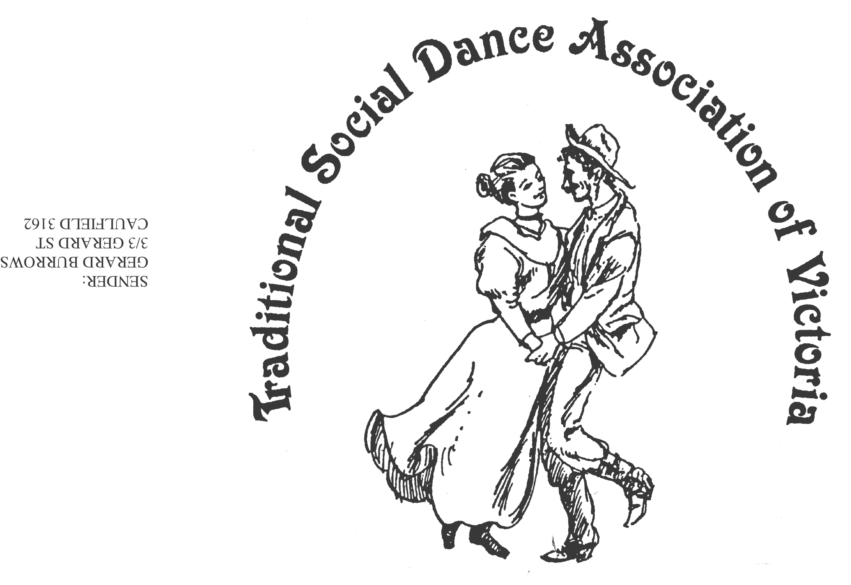Spring Dance Weekend

**7th–9th November 2025**

**PARKS HALL COMMUNITY CENTRE**

**Portarlington**

(1.5 hrs drive SW of Melbourne, 20 minutes past Geelong. Or catch the ferry)

Come Dressed as a Dance

Dance workshops: Keith Wood (Australian & Contra), Ian Kendall (Welsh),

Roger Gifford (Scandinavian), Darren Taylor (Square Dancing),

Jane Bullock/George Ansell (English)

*PLUS, two evenings of social dancing*

***Dance Programme***

Friday Evening: **Welcome Dance** and Registration with drinks and nibbles

Saturday Night: **Dance Social** (themed if you wish)*~ with guest musicians*

Sunday Afternoon: Wind down with a **Farewell Dance**

***Workshop Programme***

Saturday/Sunday: 6 dance workshops, 1 dance music session

***For Information****: Norm Ellis 03 9888 5332*

*or George Ansell 03 9890 5650*

*or Judith Baillie 0431 188 026*

**Website:** [**http://tsdav.asn.au/events**](http://tsdav.asn.au/events)

## Programme for the Weekend

|  |  |  |  |  |
| --- | --- | --- | --- | --- |
| **Day** | **Event** | **Workshop Title** & **Presenter** | | |
| **Friday night** | ***Registration***  from 7.30 pm | *with drinks and nibbles* | | |
|  | ***Welcome Dance***  from 8.00 pm | **Informal night of simple social dancing**  with guest callers | | |
| **Saturday** | ***Registration***  from 9.00am | *at the Hall* | | |
|  | ***Dance Workshop***  9.30 – 11.00 | **“Modern Australian Dances”** | | **Keith Wood**  (Sydney) |
|  | ***Dance Workshop***  11.15 – 12.45 | **“Welsh Country Dances”** | | **Ian Kendall**  (Melbourne) |
|  | ***Dance Workshop***  1.45 – 3.15 | **“Diverse Nordic Folk Dances”** | | **Roger Gifford**  (Canberra) |
|  | ***Dance Workshop***  3.30 – 5.00 | **“Introduction to Modern Square Dancing”** | | **Darren Taylor**  (Melbourne) |
| **Saturday night** | ***Evening Dance***  from 7.30 pm |  | **“Come Dressed as a Dance” Social**  ***- with music from Denise, Robert et al - MC Norm Ellis*** | |
| **Sunday** | ***Dance Workshop***  9.45 – 11.15 | **“A Tribute to Jane Austen”** | | **Jane & George**  (Melbourne) |
|  | ***Dance Workshop***  11.30 – 1.00 | **“Contra”** | | **Keith Wood**  (Sydney) |
|  | ***Farewell Dance***  2.00 – 3.30 | **“Farewell Dance”** | | **Norm Ellis**  (Melbourne) |
|  | ***Weekend Finale***  3.30 | **Farewell**  **Afternoon Tea** | |  |

**Food Arrangements**

**All morning & afternoon teas:** Provided by the TSDAV

**Lunches:** BYO, or from the local bakeries

**Saturday evening:** Light supper provided during evening dance

Cafes, restaurants, hotels, etc. are available in town.

**accommodation:** *you will need to organise your own accommodation for the weekend.*

**OUR PRESENTERS**

**DARREN TAYLOR** Darren started Square Dancing in 1987 and started Calling in 1990, calling at many Australian State and National Square Dance Conventions, he also calls regularly in the USA and has also called in New Zealand and in Europe. Darren actively teaches other Callers, and is the Club Caller for the Geelong Square Dance Club (30 Years) & Essendon Square Dance Club. Darren has been awarded the ACF Silver Microphone Award and Callerlab Quater Century Award, he is a Staff Caller on Goldrush Records and Guest Caller on Throwback Tunes record company.

**IAN KENDALL** heads the Ceffyl Gwyn Welsh Dancers, a Melbourne-based group that has performed regularly at the National Folk Festival, the National Celtic Festival and, more recently, at the Melbourne Highland Games and Celtic Festival. Welsh dance has much in common with English and Scottish country dancing but differs mainly in its style, the music, and the complex nature of some of the non-progressive dances. An experienced teacher, Ian has also written several dances in the traditional Welsh style, two of which have won TSDAV awards.

**KEITH WOOD** has been calling dances for many years, usually in Contra and English Country styles, at regular dance workshops in Sydney.  He also composes dances in these styles and in Australian and Scottish Country styles and has published five books of his dances so far.  His dances have won dance-writing competitions within Australia. He also dabbles with computers and has made [animations of many dances](http://www.dancekaleidoscope.au/dance.html) available.

**JANE BULLOCK** Widely known in Melbourne's folk-dance scene and nationally Jane is a prolific dance composer, and caller of bush, Colonial, English, Welsh and Contra. Jane calls regularly at dances, balls and festivals across Australia including the NFF. Jane's expertise is recognized internationally having called in Australia and overseas. **GEORGE ANSELL** came to live in Melbourne in 1989 joining several of the local dance groups and has run the English dancing in Melbourne since 2003. He has organised the TSDAV dance competition for the past 17 years and this workshop will include some of the varied competition dances.

**NORM ELLIS** was along with Shirley Andrews and Bruce McClure, a founding member of the TSDAV, and instigator of the Dance Composers’ Competition. A keen dancer, caller and dance teacher of many years standing, Norm will present a selection of dances from the weekend to send us off in a Farewell Dance.

**ROGER GIFFORD** Roger and Christine Gifford have run the Canberra Nordic Folkdance Group - sCanDans – since 2000 presenting many performances and workshops in Australia. As pupils, they have attended Nordic dance workshops in Denmark, Sweden, USA and UK. Roger is also a regular caller for the Canberra Contra Club.

**Our DANCE MUSICIANS: Robert Stephens** is a long-time veteran of Melbourne and Interstate music scenes, performing with piano, accordion, guitar and vocals. He has been a lead musician in the Melbourne Colonial Dancers Band for 20 years. **Maggie Duncan** is an experienced fiddle player and music teacher who has performed widely, including playing in many bush bands, and contra and old-time bands. **Jean McConnachie** is a leading fiddle player with the Melbourne Scottish Fiddle Club and this year performed with the group on tour in Canada. **Lisa Christensen** is a former fiddle player with the Melbourne Scottish Fiddle Club and on the music CD Growling Dogs (Australian Fiddle Tunes) produced by Greg O’Leary in 2002. **Denise Hibbs** is known through her long involvement with Melbourne Colonial Dancers. She is a dancer and fiddle/mandolin player and has been leader of the MCD band for 25 years. **Richard Ayling** plays mandolin in the MCD band and is an administrator of australianfolkmusic.com.au where you can view several volumes of dance music researched and produced in collaboration with Denise. **Katy Cottrill and Bryce Russell** perform on double bass and guitar and are long time members of the Victorian Folk Music Club. All band members are particularly passionate about the preservation and playing of early Australian collected dance tunes and play for regular dances and balls in Melbourne, and for events at various festivals around the country. This has included playing for several Heritage Balls at the National Folk Festival in Canberra.

**TSDAV Spring Dance Weekend 2025 Ticket Prices**

|  |  |
| --- | --- |
| **Weekend Ticket** | $95 |
| **Saturday all day and evening** | $70 |
| **Saturday evening dance only** | $20 |
| **Single session only** | $15 |

**✂- - - - - - - - - - - - - - - - - - - - - - - - - - - - - - - - - - - - - - - - - - - - - - - - - - - - - - - - - - - - - - - - - - - - -**

**APPLICATION FORM**

**I/we would like tickets for the TSDAV 2025 Spring Dance Weekend**

*If more than one applicant, please list all names/addresses*

**Name(s): . . . . . . . . . . . . . . . . . . . . . . . . . . . . . . . . . . . . . . . . . . . . . . . . . . . . . . . . . .**

**Address: . . . . . . . . . . . . . . . . . . . . . . . . . . . . . . . . . . . . . . . . . . . . . . . . . . . . . . . . . .**

**Email: . . . . . . . . . . . . . . . . . . . . . . . . . . . . . . . . . . . . . . . .** **Tel: . . . . . . . . . . . . . . . . .**

**Emergency contact: . . . . . . . . . . . . . . . . . . . . . . . . . . . .**  **Tel: . . . . . . . . . . . . . . . . .**

**Any special dietary requirements (or none): . . . . . . . . . . . . . . . . . . . . . . . . . . . . .**

**Number required Total**

 

**___**x **Weekend tickets @ $95** $ ____

**___**x **Saturday all-day tickets @ $70** $ ____

**TSDAV membership per registration included in above**

**___**x **Saturday night dance only @ $20** $ ____

**___**x **Single session @ $15** $ ____

**Total : $ ____**

** ** When booking we need the information on this form!

**NB - No payment accepted without a fully completed application form.**

EFT payment to NAME: Norm Ellis BSB: 633-000 ACCOUNT: 219371150

AND **MUST BE ACCOMPANIED** **BY YOUR** name in the reference field

AND email this form to: [george.ansell@bigpond.com](mailto:george.ansell@bigpond.com)

Cash or cheques made out to TSDAV, with this completed form, to be sent to:

***George Ansell, TSDAV, 62 Wellman St. Box Hill South, VIC 3128***

***or any TSDAV committee member***