TSDAV Spring Dance Weekend 2022 Ticket Price
A flat rate  TSDAV members  & non-members  as membership is included in this charge | $60

- - - - - - - - - - - - - - - - - - - - - - - - - - - - - - - - - - - - - - - - - - - - - - - - - - - - - - - - - - - - - - - - - - - - -
APPLICATION FORM

I/we would like tickets for the TSDAV 2022 Spring Dance Weekend
If more than one applicant, please list all names/addresses

Name(s): . . . . . . . . . . . . . . . . . . . . . . . . . . . . . . . . . . . . . . . . . Tel: . . . . . . . . . . . .

Address: . . . . . . . . . . . . . . . . . . . . . . . . . . . . . . . . . . . . . . . . . . . . . . . . . . . . . . . . . . .

Email: . . . . . . . . . . . . . . . . . . . . . . . . . . . . . . . . . . . . . . . . . . . . . . . . . . . . . . . . . . . . .

Any special dietary requirements (or none): . . . . . . . . . . . . . . . . . . . . . . . . . . . . . . .

Number required Total
 
___x registration tickets @ $60 $ ____

TSDAV membership per registration
is included
Total : $ ____

  When booking we need the information on this form!
NB - No payment accepted without a fully completed application form.
EFT can be accepted to BSB 013-375 Account 3118 25659
BUT MUST BE ACCOMPANIED by your name in the reference field
AND email this form to:
george.ansell@bigpond.com

Cash or cheques made out to TSDAV, with this completed form, to be sent to:

George Ansell, TSDAV, 62 Wellman St. Box Hill South, VIC 3128

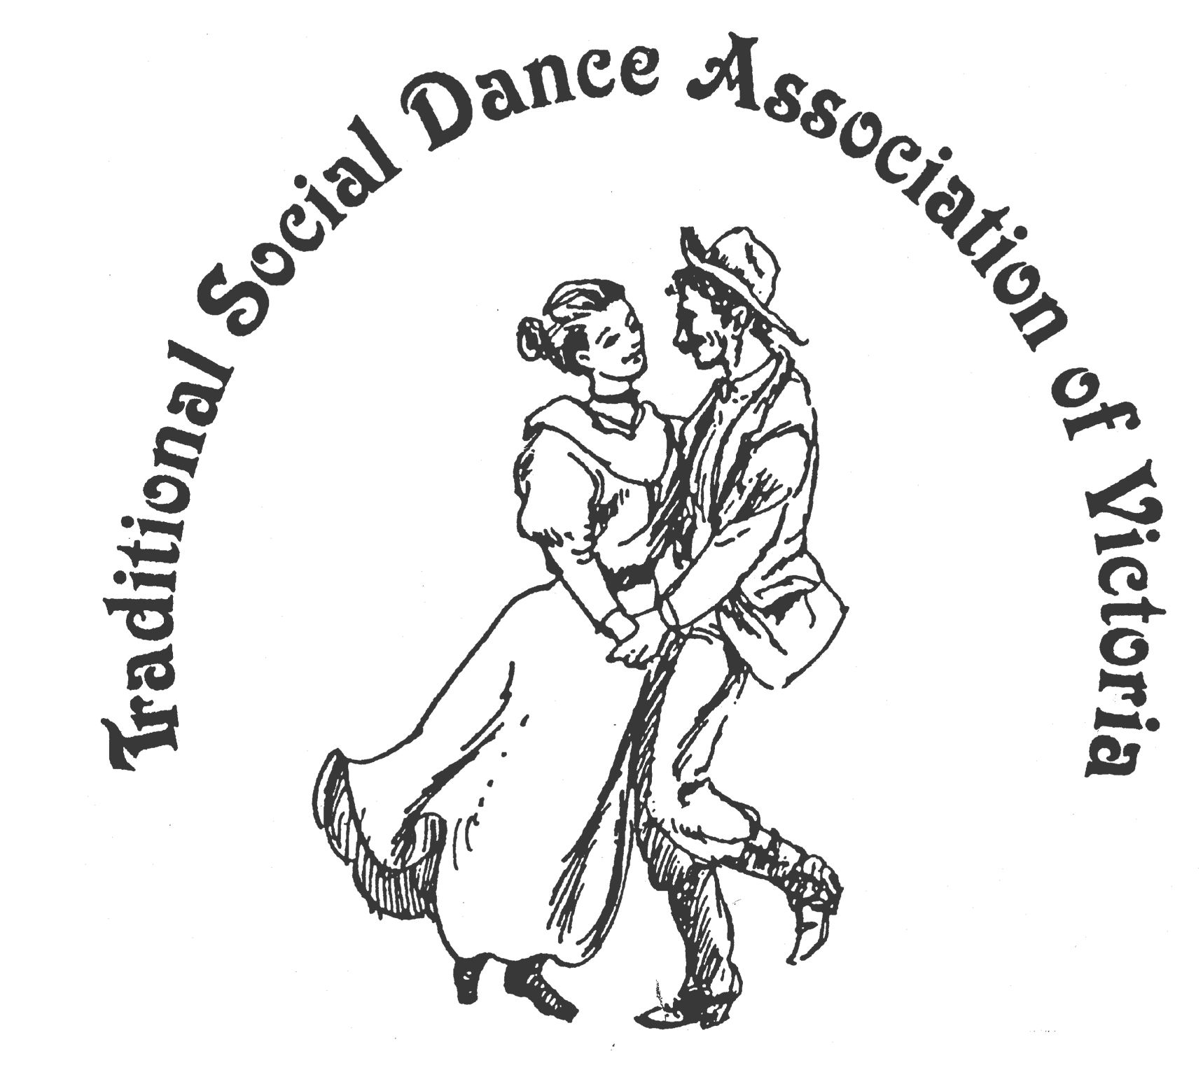
Spring Dance Weekend

12th –13th November 2022

PARKS HALL COMMUNITY CENTRE
Portarlington
(1.5 hrs drive SW of Melbourne, 20 minutes past Geelong. Or catch the ferry. Melway P.239 F2)

Many Happy Returns !

Keith Wood - English, & Australian,
Kim South - Scottish, Darren Taylor - Square Dancing

Workshop Programme
Saturday: 4 dance workshops

Dance Programme
Saturday Night: A happy return to Social Dancing ~ with guest musicians
Sunday: Wind down with a BYO picnic/BBQ lunch in the park &
Sunday Afternoon: If weather permits, an informal Contra Dance in the park

For Information: Norm Ellis 03 9888 5332
or George Ansell 03 9890 5650
or Judith Baillie 0431 188 026

Website: http://tsdav.asn.au/events

Programme for the Weekend

Day | Event | Performer, Musician & Topic
Friday night | informal  from 7.00 pm | ‘Fish & Chips’ meal -  for those who are already in town
Saturday | Registration  from 9.30 am | at the Hall
 | Dance Workshop  10.00 – 11.30 | “English” |  | Keith Wood  (Sydney)
 | Dance Workshop  11.45 – 1.15 | “Scottish Country” |  | Kim South  (Geelong)
 | Dance Workshop  2.15 – 3.45 | “Modern Square Dancing” |  | Darren Taylor  (Geelong)
 | Dance Workshop  4.00 – 5.30 | “Australian” |  | Keith Wood  (Sydney)
Saturday night | Evening Dance  from 7.30 pm |  | “Many Happy Returns!” Social  - with music from Denise, Robert, et al
Sunday | Picnic in the Park  11.00 onward | An informal BYO Picnic  followed by (if weather permits) -  Contra in the Park

programme: May be subject to change at short notice
COVID Protocol:
We will take all COVID care possible - We ask you to please wear a mask (unless you are exempt), check government website, and stay at home if you have any symptoms
Food Arrangements:
Morning & afternoon tea: Provided by the TSDAV
Lunches: get your own - from a local bakery, et al
Saturday evening: Light supper provided during evening dance
Cafes, restaurants, hotels, etc. are available in town.
accommodation: Ring contacts listed here if needing information:
Dylene Caravan Park: 0418310553 (they like 2-night bookings in Nov)
Portarlington Beach Motel: 03 5259 3801 (they have a 3-room apartment & Motel rooms)
Other accommodation available in town.
Website: http://tsdav.asn.au/events

OUR PRESENTERS

KEITH WOOD has been calling dances for several years, usually in Contra and English Country styles, at regular dance workshops in Sydney. He also composes dances in these styles and in Australian and Scottish Country styles and has published three books of his dances so far. His dances have won dance writing competitions within Australia.

KIM SOUTH was brought up with a deep love of her Scottish ancestry and began Highland Dancing at the age of 10. This led to Scottish Country Dancing as a teenager. She has been dancing for over thirty years and teaching in Geelong and surrounds for about twenty of those years. She nominates as one of the highlights of her dancing life the opportunity to visit Scotland and dance to the abundance of live music there.

DARREN TAYLOR Darren started square dancing in 1987 and started calling in 1990. He is very active in arranging and calling at many Australian state and national Square Dance conventions. He has also called at 6 conventions in the USA and 1 in New Zealand. Since 1996, Darren has been the Club Caller for the Geelong Club Dancers.

“Many Happy Returns !”
~ ~ ~

