The 25THAnnual
Dinki Di Old Time Ball
Saturday 16th September 2023
8:00pm till late
ST ANDREWS CHURCH HALL MYERS ST BENDIGO
Supper
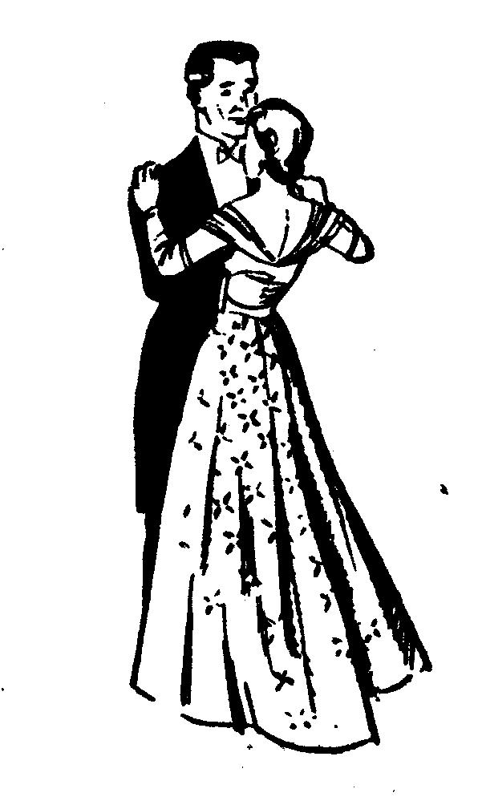

Emu Creek Bush Band Gay Charmers
Tickets if pre-paid by 9th September$20 or $25 at the door
Dress: Formal, Semi-Formal or Period. Raffle, Lucky Door & Spot prizes.
Dianne (03) 5442 1715 /0418 172 286 or Mary 5442 1153
email: secretary@bendigobushdance.org.au Bush Dance & Music Club Inc: PO BOX 922 Bendigo 3550

DINKI DI BALL PROGRAM 2023.

1.CIRCULAR WALTZ & WALTZ OXFORD
2. GYSPY TAP
3. GALOPEDE
4. MAXINA
5. POLKAS :- PRINCESS, VARSOVIANA, POLKA MAZURKA
6. FOX TROT MONTIE CARLO
7. PRIDE OF ERIN
8. DOUBLE CHAIN QUADRILLE
9. CHARMAINE
10. TANGOETTE
11. BARN DANCE & PROGRESSIVE JIVE
12. ST BERNARD WALTZ
13. GRAND MARCH & LANCERS
14. MERRILYN
15. EVENING 3 STEP
16. WALTZ COTILLIONS
17. PROGRESSIVE GORDONS
18. MODERN WALTZ
19. ALBERTS
20. PALMA WALTZ
21. DOROTHEA WALTZ
22. MILITARY 2 STEP
23. CIRCLE WALTZ

EXTRAS:- DASHING WHITE SERGEANT,
SWING WALTZ, CANADIAN BARN DANCE.

